

NAME : BISMA FATIMA
CLASS : CS A 24
ROLL NO : F24605036
COURSE : DLD LAB
COURSE CODE : CS-131
LECTURER : MISS TEHREEM KHALIL

LAB 02

Report on 1st lab task
Series Circuit Experiment
Objective:
To investigate the behavior of a series circuit using resistors, LED bulbs, and jumper wires.
Materials:
- Resistors
- LED bulbs
- Jumper wires
- Trainer kit
Procedure:
The resistors, LED bulbs, and jumper wires were connected in a series circuit configuration using the trainer kit.
Observations:
The LED bulbs lit up, indicating that the circuit was complete and functional. The resistors helped to regulate the current flowing through the circuit.
FIGURE
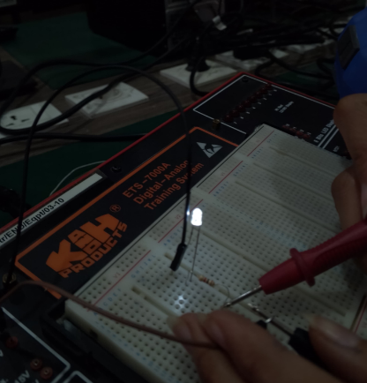

Measurements using Digital Multimeter
A digital multimeter was used to measure the resistance, voltage, and current in the circuit. The measurements provided accurate values for:
- Resistance (Ω)
- Voltage (V)
- Current (A)
These measurements helped to verify the circuit's behavior and ensured that the components were functioning within expected parameters.
FIGURE


Following are the readings we have taken in lab :
FIGURE
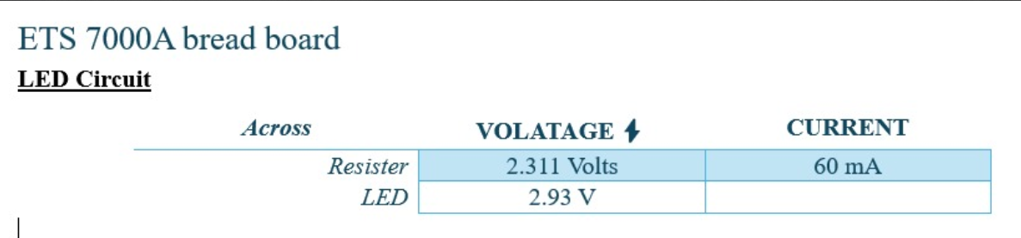
Digital Display:
Using digital bits, we generated a numerical display, demonstrating the fundamental concept of digital representation.
We generated our “roll no” in digital display, my roll no is 36 , so we on “4” , “2” bits from left and “2” , “1” from the right.
FIGURE

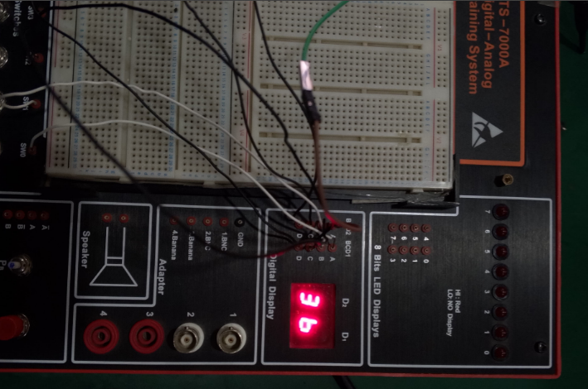

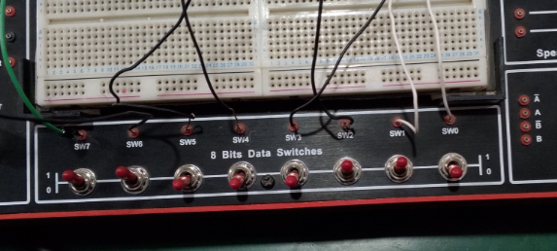

LED Display:
The LED display showed the numerical value represented by the digital bits, providing a visual representation of the binary code.

In the following figures we have “on” and “off” different bits.
- In 1st figure we have “2” and “7” only bits, off remaining are on.
- In 1st figure we have “7” only bit, off remaining are on.

FIGUREs

